Aim :-
To enhance five different degraded images using suitable gray-level transformation techniques and analyze the effectiveness of each technique in improving the visual quality of the images.
Theory:-
Gray-level transformation is a basic technique in Digital Image Processing used to improve the visual quality of degraded images by changing their pixel intensity values. Different transformations are selected depending on the type of degradation present in an image, such as poor brightness, low contrast, or unclear details. Common gray-level transformations include image negative, thresholding, logarithmic transformation, and power-law (gamma) transformation. Image negative reverses the intensity values of pixels, while thresholding separates an image into different regions based on a selected intensity value. Logarithmic transformation is useful for enhancing details in darker intensity regions, whereas gamma transformation adjusts the brightness and contrast of an image using a gamma value. By applying a suitable transformation, important features of a degraded image can become more visible and easier to analyze. In this experiment, suitable gray-level transformation techniques are applied to the given degraded images, and the visual improvement produced by each technique is observed and analyzed.
Image 1 — Contrast Stretching:-
Contrast stretching is a gray-level transformation technique used to improve the contrast of an image by expanding its existing range of pixel intensities. If an image uses only a small portion of the available 0–255 grayscale range, it may appear dull or have low contrast. Contrast stretching maps the minimum intensity value of the original image to 0 and the maximum intensity value to 255. The intermediate pixel values are proportionally distributed between these two limits. This makes dark regions darker, bright regions brighter, and overall image details more visible. In this program, the minimum and maximum pixel values are obtained using np.min() and np.max(), and the image is then transformed using the contrast-stretching formula. The histograms before and after processing are also displayed to observe how the intensity distribution changes.

Explanation
1. Import the required libraries
import cv2
import numpy as np
import matplotlib.pyplot as plt
- cv2 is used to read the image.
- numpy is used for pixel and mathematical operations.
- matplotlib.pyplot is used to display images and histograms.
2. Read the image in grayscale
src_image = cv2.imread("ex1_1.png", cv2.IMREAD_GRAYSCALE)
The image ex1_1.png is loaded as a grayscale image, where each pixel has an intensity value between 0 and 255.
3. Check whether the image is loaded
if src_image is None:
print("Image not found!")
exit()
This checks whether the image was successfully loaded. If it is not found, the program displays an error message and stops.
4. Find the minimum and maximum intensity values
r_min = np.min(src_image)
r_max = np.max(src_image)
r_min stores the smallest pixel intensity in the image, while r_max stores the largest pixel intensity.
5. Apply contrast stretching
stretched_image = (src_image - r_min) / (r_max - r_min) * 255
This formula expands the original intensity range to the complete 0–255 range.
The minimum intensity becomes approximately 0, and the maximum intensity becomes approximately 255.
6. Convert the result to an image format
stretched_image = np.uint8(stretched_image)
The transformed values are converted into an 8-bit unsigned integer format so that they can be displayed as a standard grayscale image.
7. Display the original image
plt.subplot(1,2,1)
plt.imshow(src_image, cmap='gray')
plt.title("Original")
plt.axis('off')
The original image is displayed on the left side.
8. Display the contrast-stretched image
plt.subplot(1,2,2)
plt.imshow(stretched_image, cmap='gray')
plt.title(f"Contrast Stretched (rmin={r_min}, rmax={r_max})")
plt.axis('off')
The enhanced image is displayed on the right side. The title also shows the minimum and maximum intensity values used for stretching.
9. Display both images
plt.show()
This displays the original and contrast-stretched images for comparison.
10. Display the histogram before enhancement
plt.subplot(1,2,1)
plt.hist(src_image.ravel(), bins=256, range=(0,255))
plt.title("Histogram Before")
The histogram shows how the pixel intensity values are distributed in the original image.
11. Display the histogram after enhancement
plt.subplot(1,2,2)
plt.hist(stretched_image.ravel(), bins=256, range=(0,255))
plt.title("Histogram After")
This histogram shows the intensity distribution after contrast stretching.
12. Display the histograms
plt.show()
The two histograms are displayed so that the changes in intensity distribution can be compared.
Expected Output
The program will display the original image and contrast-stretched image side by side. It will then display the histogram before and histogram after contrast stretching. The enhanced image is expected to have better contrast and more clearly visible intensity differences.

Code:-
import cv2
import numpy as np
import matplotlib.pyplot as plt
# Read image in grayscale
src_image = cv2.imread("ex1_1.png", cv2.IMREAD_GRAYSCALE)
if src_image is None:
print("Image not found!")
exit()
# -------------------------
# Contrast Stretching
# -------------------------
r_min = np.min(src_image)
r_max = np.max(src_image)

stretched_image = (src_image - r_min) / (r_max - r_min) * 255
stretched_image = np.uint8(stretched_image)

# -------------------------
# Display Images
# -------------------------
plt.figure(figsize=(10,5))

plt.subplot(1,2,1)
plt.imshow(src_image, cmap='gray')
plt.title("Original")
plt.axis('off')

plt.subplot(1,2,2)
plt.imshow(stretched_image, cmap='gray')
plt.title(f"Contrast Stretched (rmin={r_min}, rmax={r_max})")
plt.axis('off')

plt.show()

# -------------------------
# Histograms
# -------------------------
plt.figure(figsize=(10,4))
plt.subplot(1,2,1)
plt.hist(src_image.ravel(), bins=256, range=(0,255))
plt.title("Histogram Before")
plt.subplot(1,2,2)
plt.hist(stretched_image.ravel(), bins=256, range=(0,255))
plt.title("Histogram After")
plt.show()
Output:-
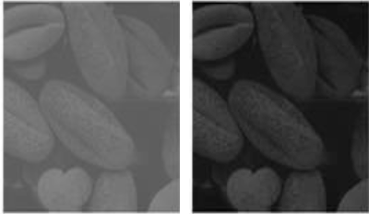

Observation
The original image had a relatively limited range of intensity values, which resulted in lower contrast and less visible details. Contrast stretching expanded the pixel intensity range from the original minimum and maximum values toward the full 0–255 range. After enhancement, the darker regions became more distinguishable and the brighter regions became more prominent. The overall contrast of the image improved, making important features easier to observe. The histogram after processing also showed a wider distribution of intensity values compared with the original image. Therefore, contrast stretching effectively improved the visual quality of this degraded image.

Image 2 — Histogram Equalization:-
Histogram equalization is a gray-level transformation technique used to improve the contrast of an image by redistributing its pixel intensity values. When an image has most of its pixels concentrated within a narrow intensity range, it may appear too dark, too bright, or have poor contrast. Histogram equalization spreads the intensity values over a wider range of the available grayscale levels, which can make important image details more visible. In this technique, the frequency distribution of the original pixel values is analyzed and transformed to produce a more balanced intensity distribution. In the given program, cv2.equalizeHist() is used to perform histogram equalization on the grayscale image. The original and equalized images are displayed side by side to observe the visual improvement. The histograms before and after equalization are also plotted to compare how the pixel intensity distribution changes after processing. Overall, histogram equalization is useful for improving image contrast and enhancing details in images with an uneven or narrow intensity distribution.
Explanation
1. Import the required libraries
import cv2
import matplotlib.pyplot as plt
- cv2 is used for image processing.
- matplotlib.pyplot is used to display the images and histograms.
2. Read the image in grayscale
src_image = cv2.imread("ex1_2.png", cv2.IMREAD_GRAYSCALE)
The image ex1_2.png is loaded in grayscale mode. Each pixel has an intensity value between 0 and 255.
3. Check whether the image is loaded
if src_image is None:
print("Image not found!")
exit()
This checks whether the image was successfully loaded. If the image is not found, the program displays an error message and stops.
4. Apply Histogram Equalization
equalized_image = cv2.equalizeHist(src_image)
The cv2.equalizeHist() function performs histogram equalization on the grayscale image. It redistributes the pixel intensity values to improve the overall contrast of the image.
5. Create a figure for displaying images
plt.figure(figsize=(10,5))
A figure is created with a suitable size to display the original and equalized images side by side.
6. Display the original image
plt.subplot(1,2,1)
plt.imshow(src_image, cmap='gray')
plt.title("Original")
plt.axis('off')
The original grayscale image is displayed on the left side.
7. Display the equalized image
plt.subplot(1,2,2)
plt.imshow(equalized_image, cmap='gray')
plt.title("Histogram Equalized")
plt.axis('off')
The histogram-equalized image is displayed on the right side. This allows the original and enhanced images to be compared easily.
8. Display the images
plt.show()
The original and equalized images are displayed.
9. Display the histogram before enhancement
plt.subplot(1,2,1)
plt.hist(src_image.ravel(), bins=256, range=(0,255))
plt.title("Histogram Before")
The histogram of the original image is displayed. It shows how the pixel intensity values are distributed before equalization.
10. Display the histogram after enhancement
plt.subplot(1,2,2)
plt.hist(equalized_image.ravel(), bins=256, range=(0,255))
plt.title("Histogram After")
The histogram of the equalized image is displayed. It helps us observe how the intensity distribution has changed after processing.
11. Display the histograms
plt.show()
Expected Output
The program will display the original image and histogram-equalized image side by side. It will then display the histogram before and histogram after equalization. The equalized image is expected to have improved contrast, making image details more visible.

Code:-
import cv2
import matplotlib.pyplot as plt
src_image = cv2.imread("ex1_2.png", cv2.IMREAD_GRAYSCALE)
if src_image is None:
print("Image not found!")
exit()
# -------------------------
# Histogram Equalization
# -------------------------
equalized_image = cv2.equalizeHist(src_image)

# -------------------------
# Display Images
# -------------------------
plt.figure(figsize=(10,5))

plt.subplot(1,2,1)
plt.imshow(src_image, cmap='gray')
plt.title("Original")
plt.axis('off')

plt.subplot(1,2,2)
plt.imshow(equalized_image, cmap='gray')
plt.title("Histogram Equalized")
plt.axis('off')

plt.show()

# -------------------------
# Histograms
# -------------------------
plt.figure(figsize=(10,4))
plt.subplot(1,2,1)
plt.hist(src_image.ravel(), bins=256, range=(0,255))
plt.title("Histogram Before")

plt.subplot(1,2,2)
plt.hist(equalized_image.ravel(), bins=256, range=(0,255))
plt.title("Histogram After")
plt.show()
Output:-
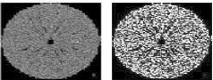
Observation
The original image had an uneven distribution of pixel intensities, which reduced the overall contrast and made some details difficult to observe. Histogram equalization redistributed the intensity values across a wider range, improving the contrast of the image. After processing, details in different regions became more visible compared with the original image. The histogram after equalization showed a more distributed intensity pattern, indicating that the available gray levels were being used more effectively. Therefore, histogram equalization improved the overall visibility and contrast of the image and was suitable for enhancing this degraded image. These two techniques satisfy the task requirement of selecting suitable gray-level transformations for degraded images and describing how each operation improves visual quality.

Image 3 — Dark, Low-Contrast Stones Image
Theory
Gamma correction, also known as power-law transformation, is a gray-level transformation technique used to adjust the brightness and intensity distribution of an image. It is especially useful for improving the visibility of details in dark or low-brightness images. The transformation is applied using the equation s = r^γ, where the input pixel value is first normalized to the range 0–1. When γ < 1, the image becomes brighter, while γ > 1 generally makes the image darker. In this program, γ = 0.5 is used to brighten the image and make details in darker regions more visible. The histograms before and after processing are also displayed to observe the change in intensity distribution.
Explanation
1. Import the required libraries
import cv2
import numpy as np
import matplotlib.pyplot as plt
- cv2 is used to read the image.
- numpy is used for mathematical and pixel intensity operations.
- matplotlib.pyplot is used to display the images and histograms.
2. Read the image in grayscale
src_image = cv2.imread("ex1_3.png", cv2.IMREAD_GRAYSCALE)
The image ex1_3.png is loaded in grayscale mode. Each pixel has an intensity value between 0 and 255.
3. Check whether the image is loaded
if src_image is None:
print("Image not found!")
exit()
This checks whether the image was successfully loaded. If the image is not found, the program displays an error message and stops.
4. Set the Gamma Value
gamma = 0.5
The gamma value is set to 0.5.
Since the gamma value is less than 1, the transformation is used to brighten the image, especially the darker regions.
5. Normalize the Image
normalized_image = src_image / 255.0
The original pixel values are between 0 and 255. Dividing by 255.0 converts them into the range 0 to 1.
This normalized image is then used for the gamma transformation.
6. Apply Gamma Correction
gamma_corrected_image = np.power(normalized_image, gamma)
The power-law transformation is applied using NumPy's np.power() function.
The transformation can be represented as:
Output = Input^γ
Here, γ = 0.5, so the darker pixel values are increased, resulting in a brighter image.
7. Convert the Image Back to 0–255 Range
gamma_corrected_image = np.uint8(gamma_corrected_image * 255)
The transformed values are initially between 0 and 1. Multiplying by 255 converts them back to the standard grayscale range.
np.uint8() converts the result into an 8-bit image format.
8. Create a Figure
plt.figure(figsize=(10,5))
A figure is created to display the original and gamma-corrected images side by side.
9. Display the Original Image
plt.subplot(1,2,1)
plt.imshow(src_image, cmap='gray')
plt.title("Original")
plt.axis('off')
The original grayscale image is displayed on the left side.
10. Display the Gamma-Corrected Image
plt.subplot(1,2,2)
plt.imshow(gamma_corrected_image, cmap='gray')
plt.title(f"Gamma Corrected (γ={gamma})")
plt.axis('off')
The gamma-corrected image is displayed on the right side.
The title also shows the gamma value used, which is 0.5.
11. Display the Images
plt.show()
The original and gamma-corrected images are displayed for comparison.
12. Display the Histogram Before Enhancement
plt.subplot(1,2,1)
plt.hist(src_image.ravel(), bins=256, range=(0,255))
plt.title("Histogram Before")
The histogram of the original image is displayed. It shows the distribution of pixel intensity values before gamma correction.
13. Display the Histogram After Enhancement
plt.subplot(1,2,2)
plt.hist(gamma_corrected_image.ravel(), bins=256, range=(0,255))
plt.title("Histogram After")
The histogram of the gamma-corrected image is displayed. This allows the intensity distribution before and after processing to be compared.
14. Display the Histograms
plt.show()
Expected Output
The program will display the original image and gamma-corrected image side by side. It will then display the histogram before and histogram after gamma correction. Since γ = 0.5, the processed image is expected to appear brighter, particularly in the darker regions.

Code:-
import cv2
import numpy as np
import matplotlib.pyplot as plt

src_image = cv2.imread("ex1_3.png", cv2.IMREAD_GRAYSCALE)

if src_image is None:
print("Image not found!")
exit()

# -------------------------
# Gamma (Power-Law) Transformation
# -------------------------
gamma = 0.5 # < 1 brightens dark images

normalized_image = src_image / 255.0
gamma_corrected_image = np.power(normalized_image, gamma)
gamma_corrected_image = np.uint8(gamma_corrected_image * 255)

# -------------------------
# Display Images
# -------------------------
plt.figure(figsize=(10,5))

plt.subplot(1,2,1)
plt.imshow(src_image, cmap='gray')
plt.title("Original")
plt.axis('off')

plt.subplot(1,2,2)
plt.imshow(gamma_corrected_image, cmap='gray')
plt.title(f"Gamma Corrected (γ={gamma})")
plt.axis('off')

plt.show()

# -------------------------
# Histograms
# -------------------------
plt.figure(figsize=(10,4))
plt.subplot(1,2,1)
plt.hist(src_image.ravel(), bins=256, range=(0,255))
plt.title("Histogram Before")
plt.subplot(1,2,2)
plt.hist(gamma_corrected_image.ravel(), bins=256, range=(0,255))
plt.title("Histogram After")
plt.show()
Output :-
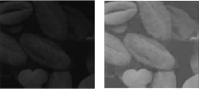
Observation
The original image appeared relatively dark, making some details difficult to observe clearly. Gamma correction with γ = 0.5 increased the intensity of the darker pixels and produced a brighter image. As a result, details present in the darker regions became more visible compared with the original image. The histogram after gamma correction also showed that the pixel intensity distribution shifted toward higher intensity values. This indicates that the transformation effectively increased the brightness of the image. Therefore, gamma correction with a gamma value less than 1 was suitable for improving the visual quality of this degraded image.

Image 4 — Log Transformation (Night Photo)
Log transformation is a gray-level transformation technique used to enhance details in the darker regions of an image. It expands the lower intensity values while compressing the higher intensity values. The transformation is generally represented as s = c log(1 + r), where r is the input pixel intensity and c is a scaling constant. In this program, the scaling constant is calculated based on the maximum pixel value so that the output remains within the 0–255 range. Log transformation is particularly useful when important image details are concentrated in low-intensity regions.
Explanation
1. Import the required libraries
import cv2
import numpy as np
import matplotlib.pyplot as plt
- cv2 is used to read the image.
- numpy is used for mathematical and pixel operations.
- matplotlib.pyplot is used to display the images and histograms.
2. Read the image in grayscale
src_image = cv2.imread("ex1_4.png", cv2.IMREAD_GRAYSCALE)
The image ex1_4.png is loaded in grayscale mode, so each pixel has an intensity value between 0 and 255.
3. Check whether the image is loaded
if src_image is None:
print("Image not found!")
exit()
This checks whether the image was successfully loaded. If the image is not found, the program displays an error message and stops.
4. Convert the image to floating-point format
src_float = src_image.astype(np.float64)
The image is converted to float64 format so that logarithmic calculations can be performed accurately.
5. Calculate the scaling constant
c = 255 / np.log(1 + np.max(src_float))
The scaling constant c is calculated using the maximum intensity value present in the image. It helps scale the transformed pixel values into the 0–255 range.
6. Apply Log Transformation
log_image = c * np.log(1 + src_float)
The logarithmic transformation is applied using:
s = c log(1 + r)
Here, r represents the original pixel intensity and s represents the transformed intensity.
The transformation expands lower intensity values and compresses higher intensity values.
7. Convert the result into a valid image
log_image = np.uint8(np.clip(log_image, 0, 255))
np.clip() keeps all pixel values between 0 and 255. Then np.uint8() converts the result into the standard 8-bit image format.
8. Display the original image
plt.subplot(1,2,1)
plt.imshow(src_image, cmap='gray')
plt.title("Original")
plt.axis('off')
The original grayscale image is displayed on the left side.
9. Display the log-transformed image
plt.subplot(1,2,2)
plt.imshow(log_image, cmap='gray')
plt.title("Log Transformed")
plt.axis('off')
The log-transformed image is displayed beside the original image so that the enhancement can be compared.
10. Display the images
plt.show()
This displays both the original and transformed images.
11. Display the histogram before transformation
plt.subplot(1,2,1)
plt.hist(src_image.ravel(), bins=256, range=(0,255))
plt.title("Histogram Before")
The histogram shows the distribution of pixel intensity values in the original image.
12. Display the histogram after transformation
plt.subplot(1,2,2)
plt.hist(log_image.ravel(), bins=256, range=(0,255))
plt.title("Histogram After")
This histogram shows how the pixel intensity distribution changes after applying log transformation.
13. Display the histograms
plt.show()
Expected Output
The program will display the original grayscale image and log-transformed image side by side. It will then display the histogram before and histogram after processing. The log-transformed image is expected to show improved visibility of details in darker intensity regions.
Code:-
import cv2
import numpy as np
import matplotlib.pyplot as plt

src_image = cv2.imread("ex1_4.png", cv2.IMREAD_GRAYSCALE)

if src_image is None:
print("Image not found!")
exit()

# -------------------------
# Log Transformation
# -------------------------
src_float = src_image.astype(np.float64)
c = 255 / np.log(1 + np.max(src_float))

log_image = c * np.log(1 + src_float)
log_image = np.uint8(np.clip(log_image, 0, 255))

# -------------------------
# Display Images
# -------------------------
plt.figure(figsize=(10,5))

plt.subplot(1,2,1)
plt.imshow(src_image, cmap='gray')
plt.title("Original")
plt.axis('off')

plt.subplot(1,2,2)
plt.imshow(log_image, cmap='gray')
plt.title("Log Transformed")
plt.axis('off')
plt.show()
# -------------------------
# Histograms
# -------------------------
plt.figure(figsize=(10,4))
plt.subplot(1,2,1)
plt.hist(src_image.ravel(), bins=256, range=(0,255))
plt.title("Histogram Before")
plt.subplot(1,2,2)
plt.hist(log_image.ravel(), bins=256, range=(0,255))
plt.title("Histogram After")
plt.show()
Output:-
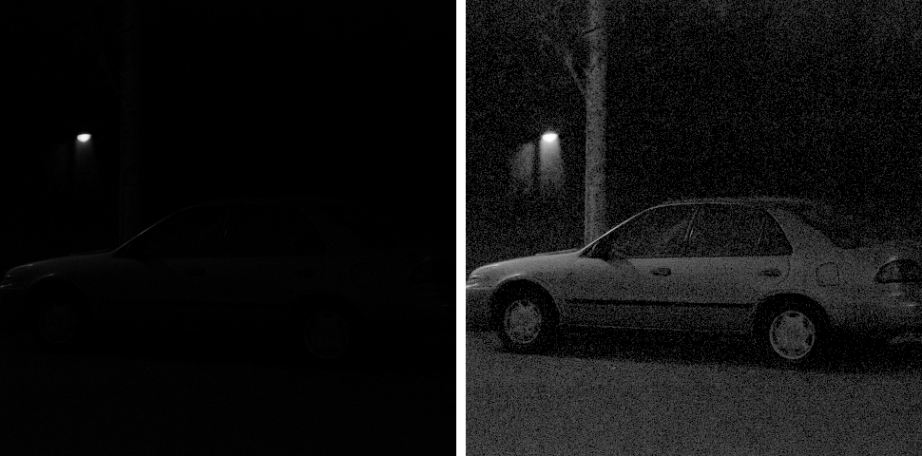
Observation
The original image contained intensity information that was not equally visible across all regions. After applying the log transformation, the lower intensity values were expanded, making details in darker areas more noticeable. At the same time, higher intensity values were compressed, preventing them from dominating the image. The histogram after transformation showed a changed intensity distribution compared with the original histogram. This indicates that the logarithmic transformation modified the gray levels to improve the visibility of low-intensity details. Therefore, log transformation was suitable for enhancing the darker regions of this degraded image.

Image 5 — Log Transformation (Dark Scan)
Log transformation is a gray-level transformation technique used to enhance details in the darker regions of an image. It expands lower intensity values while compressing higher intensity values, making details in dark areas more visible. The transformation is given by s = c log(1 + r), where r is the input pixel intensity and c is a scaling constant. In this program, the scaling constant is calculated according to the maximum intensity of the image so that the output remains within the 0–255 range.
Explanation
1. Import the required libraries
import cv2
import numpy as np
import matplotlib.pyplot as plt
- cv2 is used to read the image.
- numpy is used for mathematical and pixel operations.
- matplotlib.pyplot is used to display the images and histograms.
2. Read the image in grayscale
src_image = cv2.imread("ex1_5.png", cv2.IMREAD_GRAYSCALE)
The image ex1_5.png is loaded in grayscale mode. Each pixel has an intensity value between 0 and 255.
3. Check whether the image is loaded
if src_image is None:
print("Image not found!")
exit()
This checks whether the image was successfully loaded. If the image is not found, the program displays an error message and stops.
4. Convert the image to floating-point format
src_float = src_image.astype(np.float64)
The image is converted to float64 format so that logarithmic calculations can be performed accurately.
5. Calculate the scaling constant
c = 255 / np.log(1 + np.max(src_float))
The scaling constant c is calculated using the maximum pixel intensity of the image. It helps scale the transformed values into the 0–255 range.
6. Apply Log Transformation
log_image = c * np.log(1 + src_float)
The logarithmic transformation is applied using:
s = c log(1 + r)
Here, r represents the original pixel intensity and s represents the transformed intensity. The transformation expands lower intensity values and compresses higher intensity values.
7. Convert the result into a valid image
log_image = np.uint8(np.clip(log_image, 0, 255))
np.clip() keeps all pixel values between 0 and 255. Then np.uint8() converts the result into the standard 8-bit image format.
8. Display the original image
plt.subplot(1,2,1)
plt.imshow(src_image, cmap='gray')
plt.title("Original")
plt.axis('off')
The original grayscale image is displayed on the left side.
9. Display the log-transformed image
plt.subplot(1,2,2)
plt.imshow(log_image, cmap='gray')
plt.title("Log Transformed")
plt.axis('off')
The log-transformed image is displayed beside the original image so that the enhancement can be compared.
10. Display the images
plt.show()
This displays both the original and log-transformed images.
11. Display the histogram before transformation
plt.subplot(1,2,1)
plt.hist(src_image.ravel(), bins=256, range=(0,255))
plt.title("Histogram Before")
The histogram shows the distribution of pixel intensity values in the original image.
12. Display the histogram after transformation
plt.subplot(1,2,2)
plt.hist(log_image.ravel(), bins=256, range=(0,255))
plt.title("Histogram After")
This histogram shows how the pixel intensity distribution changes after applying log transformation.
13. Display the histograms
plt.show()
Expected Output
The program will display the original grayscale image and log-transformed image side by side. It will then display the histogram before and histogram after processing. The log-transformed image is expected to show improved visibility of details in darker intensity regions.

Code:-
import cv2
import numpy as np
import matplotlib.pyplot as plt

src_image = cv2.imread("ex1_5.png", cv2.IMREAD_GRAYSCALE)

if src_image is None:
print("Image not found!")
exit()

# -------------------------
# Log Transformation
# -------------------------
src_float = src_image.astype(np.float64)
c = 255 / np.log(1 + np.max(src_float))

log_image = c * np.log(1 + src_float)
log_image = np.uint8(np.clip(log_image, 0, 255))

# -------------------------
# Display Images
# -------------------------
plt.figure(figsize=(10,5))

plt.subplot(1,2,1)
plt.imshow(src_image, cmap='gray')
plt.title("Original")
plt.axis('off')
plt.subplot(1,2,2)
plt.imshow(log_image, cmap='gray')
plt.title("Log Transformed")
plt.axis('off')
plt.show()
# -------------------------
# Histograms
# -------------------------
plt.figure(figsize=(10,4))
plt.subplot(1,2,1)
plt.hist(src_image.ravel(), bins=256, range=(0,255))
plt.title("Histogram Before")
plt.subplot(1,2,2)
plt.hist(log_image.ravel(), bins=256, range=(0,255))
plt.title("Histogram After")
plt.show()
Output:-
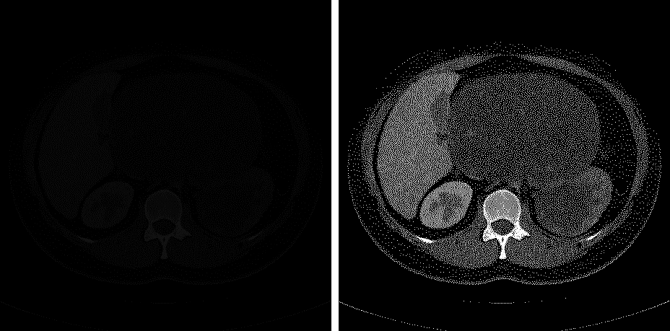
Observation
The original image was processed using log transformation to modify its gray-level distribution. The transformation expanded the lower intensity values and compressed the higher intensity values, helping to make darker details more visible. The transformed image can therefore provide better visibility of features present in low-intensity regions. The histogram after processing also showed a change in the distribution of pixel values compared with the original histogram. This indicates that the log transformation effectively modified the intensity range of the image. Overall, the technique was useful for enhancing details that were less visible in the original image.
Conclusion :-
This experiment demonstrated how different gray-level transformation techniques can be used to enhance degraded images and improve their visual quality. Contrast stretching improved the contrast by expanding the pixel intensity range, while histogram equalization redistributed the intensity values to provide better overall contrast. Gamma correction with γ = 0.5 increased the brightness and improved the visibility of darker regions. Log transformation enhanced details in low-intensity areas by expanding darker pixel values. The comparison of the original and enhanced images, along with their histograms, showed that each technique produces different results depending on the type of degradation present in the image. Overall, the experiment helped me understand that selecting the appropriate gray-level transformation is important for achieving effective image enhancement, better contrast, improved brightness, and clearer visibility of important image details.

